Que: 1. Create a new database called student_management.

use student_management

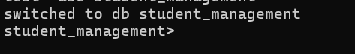

Que: 2. Create a collection called students in the student_management database.

db.createCollection("student")

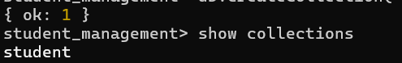

Que: 3. Insert at least five students records into the student collection. Each record should have the following fields.

db.student.insertMany([{_id:101,name:"Akshay Kumar",age:21,department:"HR",course:

... ["HTML","CSS"],grade:"C"},{_id:102,name:"Salman",age:22,department:"Computer Science",course:["Python","JavaScript"],grade:"D"},{_id:103,name:"Shahid",age:20,department:"IT",course:["Database System","PHP"],grade:"B"},{_id:104,name:"John",age:23,department:"HR",course:["Java Script","HTML"],grade:"B"},{_id:105,name:"Sunil",age:19,department:"IT",course:["PHP","C++"],grade:"A"}])

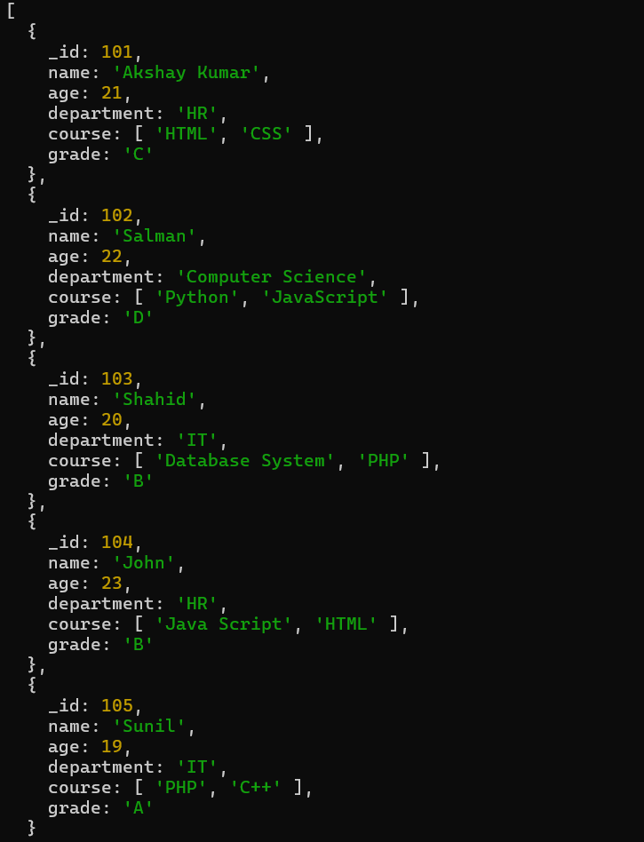

Que: 4. Query

* Retrieve all students who are in the “Computer Science” department.

db.student.find({department:"Computer Science"})

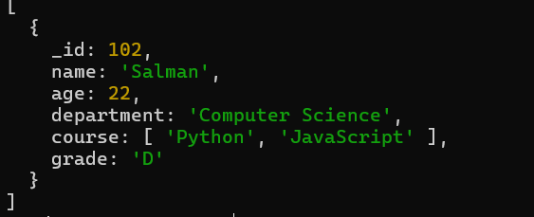

* Retrieve students who have an age is greate then 21.

db.student.find({age:{$gt:21}})

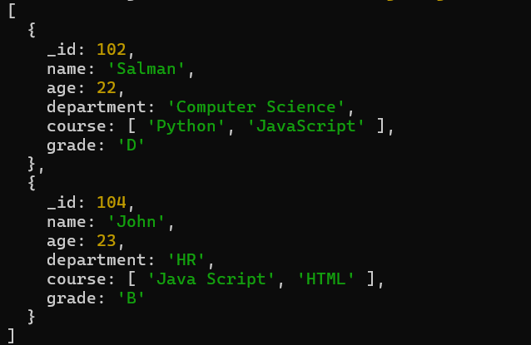

* Retrieve students who are taking the Database System course

db.student.find({course:"Database System"})

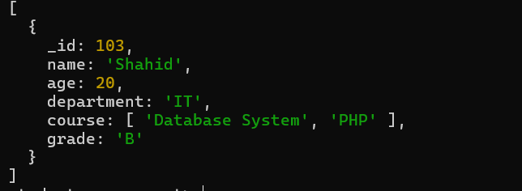

* Retrieve students with a grade “A”.

db.student.find({grade:"A"})

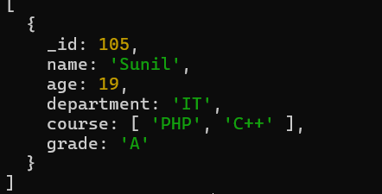

Que: 5. Update Documents.

* Update the age of a student with student_id 104 to 21.

db.student.updateOne({_id:102},{$set:{age:21}})

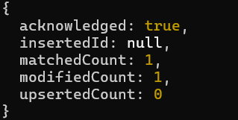

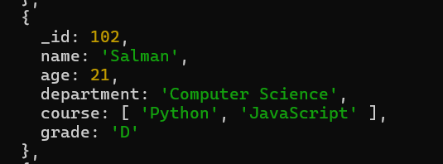

* Add a new course “Machine Learning” to the courses in the “Computer Science” department.

db.student.updateOne({department:"Computer Science"},{$push:{course:"Machine Learning"}})

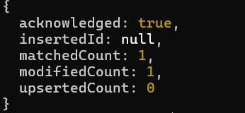

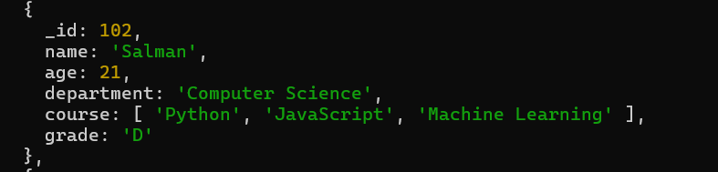

Que: 6. Delete Documents

* Delete a student record with student_id 105.

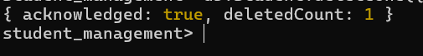

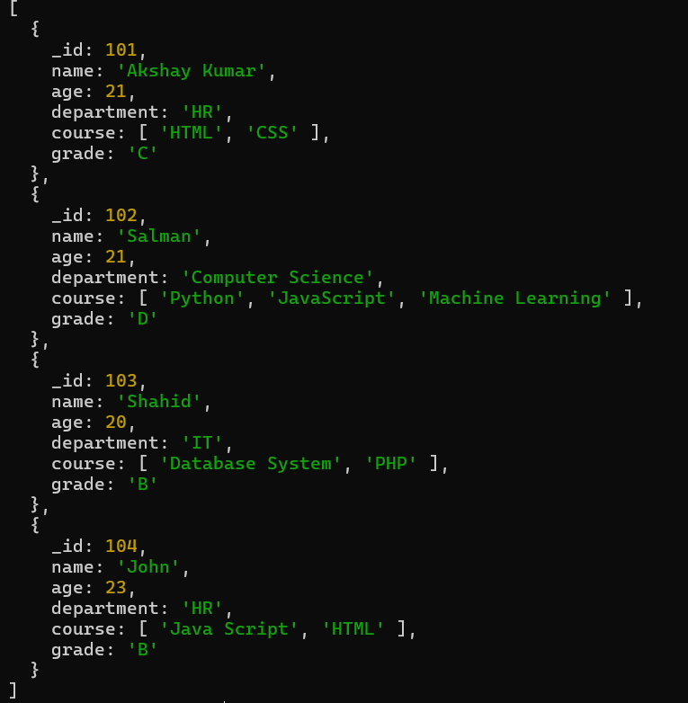

* Delete all student who have a grade lower then “C”.

db.student.deleteOne({grade:{$in:["D"]}})

